PESTECH WEBSITE RESTRUCTURING

- BOARD OF DIRECTORS DETAILS

Lim Ah Hock
Lim Ah Hock is an Executive Chairman (“EC”) of PESTECH. He was appointed to the Board on 18 August 2011.

In 1978, he graduated from the University of Strathclyde in Glasgow, United Kingdom with a Bachelor of Science Degree majoring in Mechanical Engineering (First Class Honours). He is a member of the Institute of Engineers, Malaysia (“IEM”) since 1981.

He began his career in 1979 as a Lecturer in Ngee Ann Technical College in Singapore (renamed to Ngee Ann Polytechnic in 1982) lecturing in thermodynamics and fluid mechanics. In 1980, he joined Mechmar Kejuruteraan Sdn Bhd (“Mechmar”) as a Service Engineer where he managed the service division and was involved in the provision of after- sales service and major boiler repairs. Subsequently, he left Mechmar in 1984 and joined Sing Mah Pressure Vessels Co. as a Branch Manager during the period of 1984 to 1989 where he was in charge of the Southern branch’s overall sales to the oil palm refineries, food and timber industries as well as other existing industries in Southern Peninsular, Sabah and Sarawak. In 1989, he became a Director of VESTECH Engineering Sdn Bhd, a position he holds until today.

In 1991, he set up PESTECH Sdn. Bhd. in Johor Bahru. To-date, his responsibilities in the Group include charting major corporate development plans, steering macro business growth direction together with the stewardship of the Executive Director (“ED”) cum Group Chief Executive Officer (“Group CEO”), monitor the overall financial well-being and activities of the Group which includes providing management guidance and direction to our staff.

Paul Lim Pay Chuan
Paul Lim Pay Chuan is an Executive Director cum Group CEO of PESTECH. He was appointed to the Board on 18 August 2011.

He graduated from the University of Mississippi, USA with a Bachelor of Science in Electrical Engineering (Summa Cum Laude) in 1993. Subsequently, he obtained his Master of Engineering (Electrical) from Cornell University, USA in 1994. He is currently registered as a Fellow Member of the Institute of Engineers Malaysia and a Professional Engineer with the Board of Engineers Malaysia since 2007 in the field of electrical engineering. Since 2011, he is also a certified Project Management Professional® with the Project Management Institute, a global professional association that certifies project management expertise which is based in the US with regional offices worldwide. He is registered as an ASEAN Chartered Professional Engineer since 2016. In 2017, he was registered under The Asia Pacific Economic Co-Operation Register and The International Register of Professional Engineer and the ASEAN Engineering Register.

In 1994, he began his career with Motorola Malaysia Sdn Bhd as a Product Engineer. He then joined Toprank Corporation Sdn Bhd (known as Toshiba Transmission & Distribution Systems Asia Sdn Bhd) in 1995 as a Project Engineer, where he was promoted to Project Manager in 1997, and subsequently promoted to Assistant General Manager in 1998, a position held for two (2) years. In 2000, he joined the Group as a General Manager and was promoted to CEO in 2008.

He has been playing an instrumental role in the growth and development of PESTECH from a small player primarily involved in trading, to an established homegrown integrated electric power technology company in the power transmission and distribution business with operations locally and abroad.

In 2010, he was awarded the Outstanding Entrepreneurship Award 2010 by Enterprise Asia, for his dedication and leadership in guiding the Group to being an important player in the power transmission and distribution business locally and abroad.

Ibrahim bin Talib
Ibrahim Bin Talib is the Senior Independent Non-Executive Director of PESTECH. He was appointed to the Board on 22 February 2012 as Independent Non-Executive Director on 26 October 2015. He is currently Chairman of the Nominating Committee and member of the Audit Committee and Remuneration Committee.

He graduated from Brighton University (formerly known as Brighton College of Technology) in Sussex, England with a Bachelor of Science (Honours) in Electrical Engineering in 1972. He is a member of the Institution of Engineers Malaysia since 1978, Board of Engineers Malaysia since 1979 and Council of Engineering Institution of England since 1980.

He has been involved for over 30 years in the power supply industry with Lembaga Letrik Nasional (“LLN”) [presently known as Tenaga Nasional Berhad (“TNB”)]. He started his career in the industry as a pupil engineer with TNB from 1972 to 1974. Subsequently, he rose through the ranks throughout his career in TNB and held his last position as the Head of Transmission Project under the Project Services Division of TNB in 2003 before retiring in 2004. During his tenure with TNB, he has worked with a number of divisions within TNB amongst others, engineering and design, procurement and contracts, tender and design, distribution of projects and head of district offices in Seremban and Melaka.

Lee Ting Kiat
Lee Ting Kiat is an Independent Non-Executive Director of PESTECH. He was appointed to the Board on 26 May 2017. He is currently the Chairman of the Remuneration Committee and a member of the Audit Committee and Nominating Committee.

He graduated with a Bachelor of Laws from the University of Malaya in 1991 and was admitted as an advocate and solicitor of the High Court of Malaya in May 1992. Currently, he is a practising lawyer and the Managing Partner of Messrs. Lee & Tengku Azrina, a firm set up by him and Tengku Azrina since 2005. Prior to the current firm, he was a partner in Messrs. Zaid Ibrahim & Co., at that time and presently the largest legal firm in Malaysia, from 2000 to 2005. He was also a partner in Messrs. Andrew Wong & Co. from 1995 to 1999. He did his pupillage and started his early days of practice in Messrs. Azim, Tunku Farik & Wong (previously known as Azim, Ong & Krishnan) from 1991 to 1994.

In his extensive career as a lawyer, he has wide experience in various areas of law, ranging from corporate and commercial, financing and property matters. He advises on matters relating to mergers and acquisitions, various corporate exercises, restructuring of corporations, foreign direct investment, financing matters, property development, joint venture agreements and other commercial matters. His legal firm represents a large number of local and foreign corporations, developers and banks in Malaysia on various deals.

He is also an Executive Committee Member of the Malaysian International Chamber of Commerce & Industry, Southern Region.

He is currently acting as an Independent Non-Executive Chairman of MTAG Group Berhad and also an Independent Non-Executive Director of SIG Gases Berhad. Other than that, he does not hold any other directorship in other public companies.

Tan Puay Seng
Tan Puay Seng is an Independent Non-Executive Director of PESTECH. He was appointed to the Board on 22 February 2012. He is currently the Chairman of Audit Committee and member of the Nominating Committee and Remuneration Committee.

He graduated from Nanyang University in Singapore with a Bachelor of Commerce in 1975. He was attached with Kershen, Fairfax & Co, a five (5) partners firm of Chartered Accountants based in London in 1977 and qualified as an accountant in 1982. After returning from London in 1984, he joined Tan Toh Hua & Partners as Audit Senior for a short period before moving on to Ong Boon Bah & Co. as a Branch Manager where he was responsible for the management and control of branch day- to-day operation covering clients in Melaka and Johor. He is a fellow member of the Association of Chartered Certified Accountants’ since 1988 and a member of the Malaysian Institute of Accountants since 1984. He has been involved in professional accountant practice for over 30 years and is currently practising under the name of P. S. Tan & Co as a Chartered Accountant based in Melaka, an audit firm set up by him since 1986.

- COMPANY BRIEF FOR INQUIRY FORM

PESTECH ENERGY SDN. BHD.

“PESTECH Energy is your choice of partnership for End to End Projects in Medium Voltage Systems, Smart City Digitalisation Solutions and Secondary Systems”

PESTECH Energy Sdn. Bhd. is an experienced medium voltage switchgear and control panel manufacturer, electric car charging infrastructure provider, renewable energy solution provider and electrical engineering services expert in distribution grid. We offer electrical equipment with both primary and secondary design ranging from 11kv to 33kv. Products and solutions offered includes Switchgear, Vacuum Circuit Breaker, Control Relay Panel, Advance Metering Infrastructure, Electric Vehicle Infrastructure and Smart Lighting.

SALES CONTACT DETAILS

Email Address : pensales@pestech.com.my
Contact No. : +603 7825 2186
Fax No. : +603 7845 2187

PESTECH TECHNOLOGY SDN. BHD.

PESTECH Technology Sdn. Bhd. delivers power plant automation & electrification solutions and railway system work packages including rail electrification, signalling and communication system.

We have outstanding portfolios in the power generation sector such as gas turbine controls, the balance of plant controls, instrumentations, distributed controls system, human-machine interface, generator protection, excitation system, synchronisers and full power plant automation. In addition, we collaborate with international OEMs to provide the best solutions to our customers in the Power Plant Automation & Electrification as well as Railway System.

SALES CONTACT DETAILS

Email Address : puva@pestech-technology.com (Mr. Puvanesvaran)
Contact No. : +603 7831 2186
Mobile No. : +6012 919 7400
Fax No. : +603 7832 2187

BID & PROPOSAL CONTACT DETAILS

Email Address : janice.lee@pestech-technology.com (Ms. Janice Lee)
Contact No. : +603 7831 2186
Fax No. : +603 7832 2187

PESTECH TRANSMISSION SDN. BHD.

PESTECH Transmission is an Engineering, Procurement, Construction and Commissioning (EPCC) contractor who offers the design, engineering, manufacturing, installation, testing and commissioning of high voltage (HV) and extra high voltage (EHV) transmission lines and underground cables including civil works.

SALES CONTACT DETAILS

Email Address : plc@pestech.com.my (Ms. Lynn Lim)
Contact No. : +603 7845 2186
Fax No. : +603 7845 2187

PESTECH SDN. BHD.

PESTECH Sdn. Bhd. provides engineering, procurement, construction and commissioning (EPCC) solutions with the capability to design and manage multi-disciplinary High Voltage (HV) and Extra High Voltage (EHV) electrical transmission substations.

We involve in project management, installation, testing and commissioning of electrical power facilities. We also focus on developing sustainable energy generation and development where it provides solutions in large scale solar photovoltaic (PV) systems, industrial and commercial solar rooftop solution and off grid distributed energy system.

SALES CONTACT DETAILS

Email Address : sales@pestech.com.my
Contact No. : +603 7625 2186
Fax No. : +603 7845 2187

- PRODUCTS

Category: Protection, Automation & Communication

Product Name | Control & Relay Panels (CRP)
Product Description | PESTECH’s comprehensive range of control and protection panels that is capable of enhancing power system stability, availability and reliability. It demonstrates PESTECH’s core engineering & design capabilities in protection and control systems from 11kV up to 500kV.  Products Range  - Control and Protection Panel (RTU & SCS IEC 61850 Design)  - Synchronizing Panel (Swing Type)  - Outdoor Marshaling Kiosk  - Remote Tap Changer Control Panel  - Local Control Panel for GIS Switchgear  - Energy Metering Panel  - Junction Box (various type)  Features and Benefits  - Simplex and Duplex panel designs  - Suitable for power systems from 11kV up to 500kV  - Completely metal-enclosed, free-standing, floor mounting installation  - Flush, semi-flush or surface-mounted protection equipment possible  - Dust and vermin-proof (IP42 – IP54 versions available)  - Clear mimic diagrams on the front of the panels are available to provide concise information on equipment status  With the cost-effective solutions and in-depth knowledge in control and protection design, it can meet different applications, type and configurations of substation for both new and rehabilitation projects.
Photos | https://drive.google.com/open?id=1gUurZbxcjmB7ogbtL3AVYOg8u8hC-RNZ
Brochure | Please disable the “download brochure” button.
Inquiry Button | Link to PESTECH Energy Sdn. Bhd.
Inquiry Form Email | pensales@pestech.com.my; info@pestech-international.com

Product Name | Communication & Teleprotection Panel
Product Description | We specialised in Systems Engineering that offers a unique mix of communications and protection expertise. We provide individually-designed solutions incorporating Synchoronous Digital Hierarchy (SDH) as the transmission media, and RFL Multiplexer and Teleprotection products all in one panel. This capability ensures that our solutions are ideally tailored to your unique requirements.  Designed specifically for the unique need of the harsh substation environments, comply to ANSI/ IEEE/ IEC standards with respect to RFI, SWC, EMI and Fast Transient requirement.  Key Features  - Completeness  - Flexibility  - Automation  - Simplicity  - System Support  Our principal, RFL offers a focused range if communication and relaying products for the electric utility market, which includes T1/E1 Multiplexer and SONET/SDH multiplexer, Substation Ethernet switches, a complete range of protective relays, Satellite Communications, Analogue and Digital Powerline Carrier, Coupling Equipment, Telemetry, Teleprotection, and Video systems, of which the E1 Access Multiplexer, IMUX2000 & IMUX DACs, Teleprotection GARD8000 are widely used in TNB (Malaysia) network.
Photos | https://drive.google.com/open?id=150UFRTlyzfIu96mNLTX_npNUmjjwfyRK
Brochure | Please disable the “download brochure” button.
Inquiry Button | Link to PESTECH Energy Sdn. Bhd.
Inquiry Form Email | pensales@pestech.com.my; info@pestech-international.com

Category: Medium Voltage System

Product Name | Neutral Earthing Resistor
Product Description | Neutral Earthing Resistors are widely used by power utilities to protect power transformers and power generators against fault currents.  RES is PESTECH’s brand for its NER has been fully type-tested according to IEEE32 international standards, KEMA and SIRIM. Our products are widely accepted in both local and international markets  Features  - Stainless steel resistor elements  - Galvanized Steel Enclosure provides long-lasting protection for the resistors  - Type tested to international standards
Photos | https://drive.google.com/open?id=1T_girVoCxcT6BNL2ff_T87qLnDEHOv5X
Brochure | Please disable the “download brochure” button.
Inquiry Button | Link to PESTECH Energy Sdn. Bhd.
Inquiry Form Email | pensales@pestech.com.my; info@pestech-international.com

Product Name | D-Switch Disconnector
Product Description | D-Switch is PESTECH’s brand for its neutral isolator. Its robust and reliable design has been fully type-tested to international standards (IEC 62271-102 & IEC-60694) and is certified by ASTA.  This disconnector switch is a “Double Break” isolator complete with manual or motorised operating mechanical drive suitable for both vertical and horizontal mounting.  Features  - Rigid Galvanized steel base  - Tinned copper contact clamps with stainless compression springs  - Molded aluminum alloy contact jaw  - Type tested to IEC-62271-102 & IEC-60694 (ASTA Certified)
Photos | https://drive.google.com/open?id=1eEWFNC7Eo7-_ZB5fKC-MgiB9f9Z87HIR
Brochure | Please disable the “download brochure” button.
Inquiry Button | Link to PESTECH Energy Sdn. Bhd.
Inquiry Form Email To | pensales@pestech.com.my; info@pestech-international.com

Product Name | Switchgear
Product Description | PESTECH's Single Busbar Switchgear, VAS-12 is built on proven vacuum switchgear technology, tried and tested all over the world. It has been designed by specialists with over 30 years’ experience in switchgear and power distribution.  Typical type tested ratings:  - 12kV Rated Voltage  - 630A / 1250A / 2000A Rated Current (higher ratings on request)  - 25 / 31.5kA for 3 secs Short Time Current  - 75kV Impulse Withstand Voltage (95kV on request)  The equipment has been tested to the latest IEC-62271 standards to meet all present-day requirements for medium voltage power distribution. This product complies with key IEC standards for medium voltage switchgear.  - IEC 62271-200  - IEC 62271-100  - IEC 62271-1  - IEC 62271-102  - IEC 62271-103  - IEC 60694  Features  - Metalclad, rigid construction  - Full compartmentalized  - Tested for Internal Arc Containment (IAC) up to 31.5kA/1s  - VCB employs embedded pole design for greater reliability  - Easy busbar assembly for faster installation & extension  - Reduced maintenance  - Generous cabling space  - Integral circuit-side earthing switch
Photos | https://drive.google.com/open?id=1HFByQVS1qLIYJhQO3XJfvC3z6wYaxLeK
Brochure | Please enable the “download brochure” button.  Brochure: VAS-12 Brochure
Inquiry Button | Link to PESTECH Energy Sdn. Bhd.
Inquiry Form Email To | pensales@pestech.com.my; info@pestech-international.com

Category: Digitalisation

Product Name | EV Charger
Product Description | The EV Charger is designed to be installed (both indoor and outdoor) at private houses, communal blocks, companies, reserved parking bays and other places where user authentication is not a requirement.  Key Features  - Power and speed of Level 2 for safe, reliable EV charging at home and office  - Built-in security and safety measures  - Tethered Charging Nozzle  - Neon Lighting & LED Charging Indication  - Indoor and Outdoor-rated enclosure  Types of EV Charger  - 3.7kW EV AC Charger  - 7kW EV AC Charger  - 22kW EV AC Charger
Photos | https://drive.google.com/open?id=1cSczB_Quibldmy3DshZDE3L0FThQ-bf2
Brochure | Please disable the “download brochure” button.
Inquiry Button | Link to PESTECH Energy Sdn. Bhd.
Inquiry Form Email To | pensales@pestech.com.my; info@pestech-international.com

Product Name | Cube Controller
Product Description | The SMART Grid CUBE Controller SGC-30 is a scalable communication and automation platform for demanding SMART Grid applications, which is ideally suited for micro grids, smart grid applications and distribution automation.  Based on a multi-tasking real-time operating system, a number of communication protocols the device can be used in conjunction with an integrated programmable logic controller.  Communication protocols such as IEC 61850, IEC 60870-5-101/104, DNP3 and Modbus are part of a standard communication library available on the SGC-30. Cloud interface options are based on standard JSON data format and exchange. Infoteam’s OPEN PCS programmable logic controller application is fully compliant with the IEC 61131 standard.  Key Features  - 32 Bit ARM Processor based  - 2 Configurable 10/100 T Base Ethernet Ports (HSR, PRP)  - 1 RS 232 Serial /RS485 Port Option  - Up to 3 I/O extension cubes for digital, analogue I/O modules  - Extension Cubes also suitable for additional GSM, LTE port  - 12 channel passive temperature sensor cube module option  - Partial discharge detection and other condition monitoring  - Redundant Power Supplies (Option)  - SD Memory Card Storage  - Ready to use for Micro Grid automation  - DIN Rail or Panel Mount Option
Photos | https://drive.google.com/open?id=1T_girVoCxcT6BNL2ff_T87qLnDEHOv5X
Brochure | Please enable the “download brochure” button.  Brochure: Cube Brochure
Inquiry Button | Link to PESTECH Energy Sdn. Bhd.
Inquiry Form Email To | pensales@pestech.com.my; info@pestech-international.com

- SOLUTIONS

Category: EPCC

Solution Name | EPCC
Solution Description | We provide engineering, procurement, construction and commissioning (EPCC) Solutions with the capability to design and manage multi-disciplinary HV and EHV electrical substations.
Photos | https://drive.google.com/open?id=1KnjR041tDE5-SLaE4dhZwzf82dBYHhds  https://drive.google.com/open?id=1Yq37F-uul2q9qfpghxsiY6cHP2mr5Mjs  https://drive.google.com/drive/folders/1wBHu6b_7Jj3OrbVD4_7-WBeD9oLmBr7I  https://drive.google.com/open?id=1VNN8P89EQ3pbNLsZ540kJGq9DKoJxQjf
Brochure | Please disable the “download brochure” button.
Inquiry Button | Link to PESTECH Sdn. Bhd.
Inquiry Form Email To | sales@pestech.com.my; info@pestech-international.com

Category: Transmission Line

Solution Name | Transmission Line
Solution Description | We offer the solution of the design, engineering, manufacturing, installation, testing and commissioning of high voltage (HV) and extra high voltage (EHV) transmission lines. PTR’s in-house civil engineering team is able to coordinate, design, manage and construct the civil structure aspects of our entire project.
Photos | https://drive.google.com/open?id=1qC8M-rh81uu0DK-_Uvl2yPM97m9zflX4  https://drive.google.com/open?id=1AS8-UVZKJZz0nSvjWPBeoFm0zsypPm81  https://drive.google.com/open?id=1VXVm3ZLufl8ohp37ioqxYaCl553OFmSM  https://drive.google.com/open?id=1_HwzTkfGDy2wj4AW2ABwweKKMqKYnVjP
Brochure | Please disable the “download brochure” button.
Inquiry Button | Link to PESTECH Transmission Sdn. Bhd.
Inquiry Form Email To | plc@pestech.com.my; info@pestech-international.com

Category: Underground Cables

Solution Name | Underground Cables
Solution Description | We offer solution of design, supply, install, testing and commissioning medium voltage, high voltage and extra high voltage of underground cable system.
Photos | https://drive.google.com/open?id=1qGRIHCxvrIdu0x17osXuK6mNUWSrspOA  https://drive.google.com/open?id=1fHYelaNrJXL5zJl8TsHM9W4i-dLB0l-U  https://drive.google.com/open?id=1lpyQQXJtMCtcyNXC_1KPgsKV5FueJeMa  https://drive.google.com/open?id=1U4XTPt7EQG8u11QOYaZKSMUfh2poqftS
Brochure | Please disable the “download brochure” button.
Inquiry Button | Link to PESTECH Transmission Sdn. Bhd.
Inquiry Form Email To | plc@pestech.com.my; info@pestech-international.com

Category: Power Generation

Solution Name | System Integrator for Power Plant Automation (DCS)
Solution Description | Power plant control and automation enable reliable, safe and efficient operation of power plant.  We are specialised in:  - Plant automation reliability and availability audit  - Plant automation level increase  - Plant control loop optimisation  - Plant instrumentation, machine condition monitoring, water and steam analysers, emission monitoring etc.  We are collaborating with our technical partner, Valmert, for this solution. Valmert is the leading global developer and supplier of technologies, automation and services for the pulp, paper and energy industries. Valmert’s advanced automation solutions range from single measurements to plant-wide turnkey automation projects.
Photos | TBC
Brochure | Please disable the “download brochure” button.
Inquiry Button | Link to PESTECH Technology Sdn. Bhd.
Inquiry Form Email To | puva@pestech-technology.com; info@pestech-international.com

Solution Name | Power Plant Performance Optimisation
Solution Description | Equipment performance degrades over time because of its working environment, which can cause the generation unit to operate under less than optimal conditions.  Power plant owners and operators emphasise the importance of ensuring maximum and efficient use of plant and associated major equipment in view of the rising fuel prices and regulatory pressure to reduce emission.  We support our customers by providing a performance monitoring system to identify potential problems and take preventive or corrective measures to improve equipment and plant efficiency.
Photos | TBC
Brochure | Please disable the “download brochure” button.
Inquiry Button | Link to PESTECH Technology Sdn. Bhd.
Inquiry Form Email To | puva@pestech-technology.com; info@pestech-international.com

Solution Name | Power Plant Operator Training Simulator
Solution Description | An Operator Training Simulator (OTS) enables plant operators to receive plant-specific and realistic hands-on training ahead of plant startup and commissioning and throughout the whole plant operation. In addition, it reduces plant start-up and commissioning time and cost, enables logic control and concept assessment, development of operating procedures and safe operation of the plant as well as the reduction of training time.  With vast experience in power plant processes, we are able to deliver complete high-fidelity simulator system with value add to customers. Furthermore, we have the abilities to integrate complete plant control & automation into the simulator system. It will provide a realistic training system to plant operators.  We also have capabilities to undertake project management, engineering, training and aftersales support of the simulator system, with the assistance of our technology partner.
Photos | TBC
Brochure | Please disable the “download brochure” button.
Inquiry Button | Link to PESTECH Technology Sdn. Bhd.
Inquiry Form Email To | puva@pestech-technology.com; info@pestech-international.com

Solution Name | Power Plant Information System
Solution Description | Power plant operators and maintenance personnel are often overwhelmed with real-time data from the plant. The plant-wide information management system allows the analysis and transformation of raw data into intelligent information to be presented to the operator and maintenance crew to improve efficiency. Processed data are stored for a long period to enable plant analysis with a historical basis.
Photos | TBC
Brochure | Please disable the “download brochure” button.
Inquiry Button | Link to PESTECH Technology Sdn. Bhd.
Inquiry Form Email To | puva@pestech-technology.com; info@pestech-international.com

Solution Name | Enterprise Asset Information Management
Solution Description | The life cycle of a project covers feasibility study, FED, EPC stage (Construction), Commissioning, Operation & Maintenance and Decommisioning. In every stage, a wide range of information is generated, which needs to be seamlessly exchanged between stages. Poor asset information management is a critical problem for stakeholders across the asset life cycle.  During project activities, capital costs and instances of project schedule extension significantly increase, affecting operations and maintenance, as these limit plant availability, raise operating costs throughout a facilities’ extensive lifetime and can cause environmental and safety issues that damage the reputation and survival of organisations.  Diagram: TBA
Photos | TBC
Brochure | Please disable the “download brochure” button.
Inquiry Button | Link to PESTECH Technology Sdn. Bhd.
Inquiry Form Email To | puva@pestech-technology.com; info@pestech-international.com

Solution Name | Power Plant Electrification
Solution Description | Through partnerships with equipment manufacturers, we undertake EPC scope for power plant electrification, which encompasses project management, basic and detail engineering, supply, installation and commissioning of electrical equipment with the power plant and its interconnection substation.
Photos | TBC
Brochure | Please disable the “download brochure” button.
Inquiry Button | Link to PESTECH Technology Sdn. Bhd.
Inquiry Form Email To | puva@pestech-technology.com; info@pestech-international.com

Solution Name | Large Scale Solar
Solution Description | As part of the Go-Green initiative, PESTECH is also emerging as EPCC for renewable energy mainly on solar power generation development. Backboned by a team of certified project management team, specialised engineering team and experienced construction team, we have the technical knowledge to pair with extensive industry experience in delivering a reliable and value add service in large scale solar photovoltaic (PV) system, industrial and commercial solar rooftop solution.
Photos | TBC
Brochure | Please disable the “download brochure” button.
Inquiry Button | Link to PESTECH Sdn. Bhd.
Inquiry Form Email To | sales@pestech.com.my; info@pestech-international.com

Solution Name | Commercial Rooftop Solution
Solution Description | As part of the Go-Green initiative, PESTECH is also emerging as EPCC for renewable energy mainly on solar power generation development. Backboned by a team of certified project management team, specialised engineering team and experienced construction team, we have the technical knowledge to pair with extensive industry experience in delivering a reliable and value add service in large scale solar photovoltaic (PV) system, industrial and commercial solar rooftop solution.
Photos | TBC
Brochure | Please disable the “download brochure” button.
Inquiry Button | Link to PESTECH Sdn. Bhd.
Inquiry Form Email To | sales@pestech.com.my; info@pestech-international.com

Category: Rail Electrification

Solution Name | Rail Electrification
Solution Description | PESTECH via partnership with various multinational engineering & construction companies and equipment manufacturers, undertakes EPC scope for railways control, automation and electrification.  This scope encompasses project management, basic and detail engineering, supply, installation and commissioning of electrical equipment.
Photos | https://drive.google.com/open?id=1MyS0KKw2MagTRDvF0Tna34yq7EJID1Te  https://drive.google.com/open?id=1bF_i876D_K1RuIS3Q-vCFH3zElMMrv4L  https://drive.google.com/open?id=1Z1otAJyB0YVBnEHDWd8EszAfwKmOLgSP
Brochure | Please disable the “download brochure” button.
Inquiry Button | Link to PESTECH Technology Sdn. Bhd.
Inquiry Form Email To | puva@pestech-technology.com; info@pestech-international.com

Solution Name | Signalling and Communication
Solution Description | Railway Signalling System is a computerised interlocking system that ensures the efficient flow of railway traffic without compromising the safety of the users. It also links up all statistics and services for communication, control and monitoring requirements.  Three (3) components of railway signalling:  - Block System  Along the railway route, the system would only allow one train to occupy a specific section of track at one time. A block system will use the train detection system (track circuit or axle counter system) to automatically detect trains in blocks and control the signals for each block.  - Automatic Train Control System  Manual operation of trains can cause errors that lead to serious accidents. The Train Control System is a mechanism that alerts the train driver to drive at a certain speed or stop the train at a certain track section. If the train driver fails to comply with the speed requirement, the Train Control System will either reduce the train speed or stop the train automatically.  - Train Traffic Control System  With the overwhelming volume of train traffic, a modernized train traffic control system is necessary for the operator to easily monitor and control train movement.
Photos | https://drive.google.com/open?id=1gwOR3yvD59DzQBOGqiAs1_csdRoHQtT0  https://drive.google.com/open?id=14CRWVwv_UWRPfBsFSFL2WwSfaqlmeEEB
Brochure | Please disable the “download brochure” button.
Inquiry Button | Link to PESTECH Technology Sdn. Bhd.
Inquiry Form Email To | puva@pestech-technology.com; info@pestech-international.com

Solution Name | Plant & Machinery
Solution Description | PESTECH has a wide range of Plant & Machineries to cater for on track rail electrification work like Unimog, the road/rail tip trucks, full set of locomotive and various type of Manco Nifty Lift Aerial Work Platform.  Having full range of rail electrification plants and machineries poised us to become your preferred electrification (Overhead catenary system and traction power system) contractor. Our plants and machineries allow fully mechanised installation of electrification works for overhead catenary system from pole planting, cantilever installation, stringing of catenary/contact wires to registration and testing & commissioning activities. Most of our plants and machineries are suitable for both rail and road operation.  All machineries had obtained local authority’s approval to carry out railway electrification work in Malaysia.  Type of Machines  - Rail Lowbed Transporter  - Road/Rail Flat Deck Truck (Unimog)  - Road/Rail Truck with Adjustable Platform (Unimog)  - Road/Rail Truck with Auger (Unimog)  - Road/Rail Excavator with Auger  - Road/Rail Manco with Work Platform (AWP)  - Road/Rail Manco with Work Platform (EWP)  - Rail Waiko with Work Platform (EWP)  - Rail Wiring Train (Clayton Loco with completed Wagon Tensioner with Crane)  - Diesel Bowser truck  - Road Auger Crane  - Road Manitou Telehandler  - Road/Rail 20T Crane with Auger 1
Photos | https://drive.google.com/open?id=1eB_BUTbzkfWTVZ3UO2cmH5Qlr8dmeA8o  https://drive.google.com/open?id=1vMzKGuoX1Eagt4QnjZoT9PzFCc0074Em
Brochure | Please enable the “download brochure” button.  Brochure: PTE Machinery
Inquiry Button | Link to PESTECH Technology Sdn. Bhd.
Inquiry Form Email To | puva@pestech-technology.com; info@pestech-international.com

Category: Digitalisation

Solution Name | Advance Metering Infrastructure
Solution Description | Advance Metering Infrastructure (AMI) is an integrated solution of smart meter, communication technology and meter data management system, specialized in using power line communication and wireless protocols to provide an end-to-end platform from hardware to communication.  Our AMI platform leverages innovative last-mile connectivity options such as PLC & Wireless protocols which allow smooth, non-disruptive installation and lower the cost of ownership.  Key Features  - Scalability: Easily transform a pilot into a deployment without any change in design or architecture.  - Flexibility: A rich set of REST APIs allows simple integration with other applications that can tap into the true power of data.  - Advance Control: Manage and control devices on-demand, in asynchronous fashion.  - Security: Implemented at all levels; cipher-based encryption with factory-installed certificates, 128-bit TLS web security.  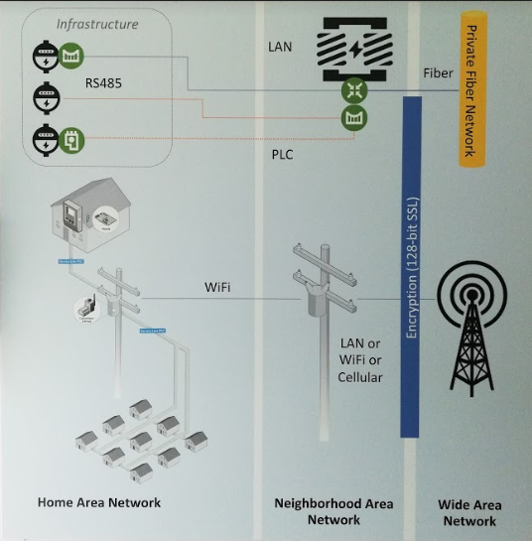  Note to Pui Ling - Please copy the diagram from  https://drive.google.com/open?id=1Xu_kfrAfIre_WQ-a9JTy9eQzzUyQ7WY9
Photos | https://drive.google.com/open?id=179Qn5ojtvQtRFuBCEw8VL4feJZtOL_jZ
Brochure | Please disable the “download brochure” button.
Inquiry Button | Link to PESTECH Energy Sdn. Bhd.
Inquiry Form Email To | pensales@pestech.com.my; info@pestech-international.com

Solution Name | EV Charging Infrastructure
Solution Description | EV Charging Infrastructure is a combination between charging solution hardware components and mobile applications, a complete solution covers hardware to software. It is flexible to integrate with Electric Car Chargers with OCPP protocol.  Key Benefits  - Flexibility to integrate with EV Chargers (with OCPP) as well as provide end-to-end solution.  - Last Mile IoT Connectivity to provide a robust, scalable & adaptable communication backbone from the charging points to the cloud platform.  - EV Charging Platform has already been developed together with TNB X to provide End User with a Mobile App with integrated Mobile Payment (eg. E-wallet, online banking, credit card) as well as Management Portal to manage a database of EV Chargers from the various sites.  Solution Architecture  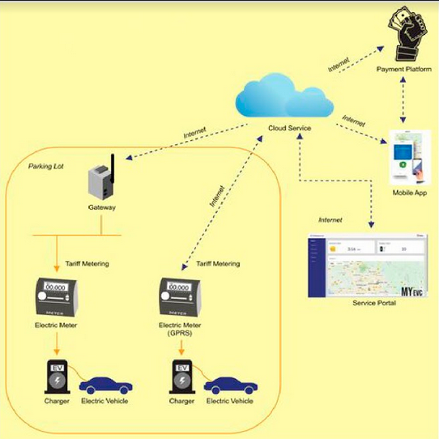  Note to Pui Ling - Please copy the diagram from  https://drive.google.com/open?id=1Bp75s38DKf3ZhYMv62G4uKpTnQ_lQkAM    myEVC APPS  myEVC is a tailor-made EV Charging apps solution where the end-user of Mobile Application can communicate to the chargers through the platform which then enables control of charging and account management. Overarching goal is to provide the users with flexibility to implement different payment models (Tariff-based or Time-of-use) and provides an overall visibility of the total EV Charging Grid.  Key Features  - Automated Point of Sales  - Mobile App with payment gateway  - Detailed Charging Statistics  - One-Click Station Details  - User Alerts on updates of charging station details  - Real-time downloadable online reports  Click Here for myEVC User Workflow  (Note to Pui Ling – the link should be directed to the pdf document)
Photos | https://drive.google.com/open?id=1R_8AWcORPl2UUrw4b4oMuiLKyfUGoS6k
Brochure | Please disable the “download brochure” button.
Inquiry Button | Link to PESTECH Energy Sdn. Bhd.
Inquiry Form Email To | pensales@pestech.com.my; info@pestech-international.com

Solution Name | Light Meter Management System
Solution Description | It uses smart controller to sense the environment and control the brightness to optimize the efficiency. Light management system is suitable to be used for street lights for smart city. Remote controlling and monitoring can be done on web portal.  Solution Architecture  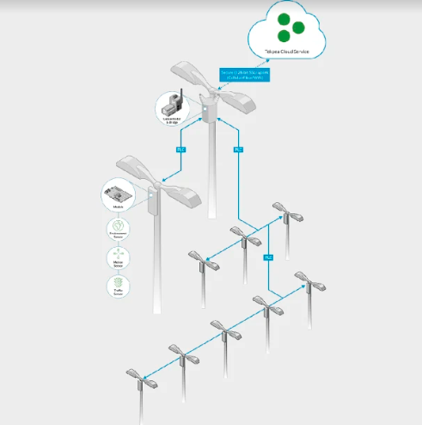  Note to Pui Ling - Please copy the diagram from https://drive.google.com/open?id=1Bp75s38DKf3ZhYMv62G4uKpTnQ_lQkAM
Photos | TBC
Brochure | Please disable the “download brochure” button.
Inquiry Button | Link to PESTECH Energy Sdn. Bhd.
Inquiry Form Email To | pensales@pestech.com.my; info@pestech-international.com

Solution Name | Rural Electrification
Solution Description | Our renewable based Micro-grid solution (“Diesel Replacement” Solution) brings electrical power to rural and remote areas.  How does it work?  - (1) During PV generation hours Energy Server supplies the load directly.  - (3) concurrently charges the storage with the excess PV generation  - (4) when PV generation ends, the Server switches energy source to storage and supplies the Load till the next morning.  - PV and Storage, are the primary source of power, supplying 100% of daily consumption and of peak load.  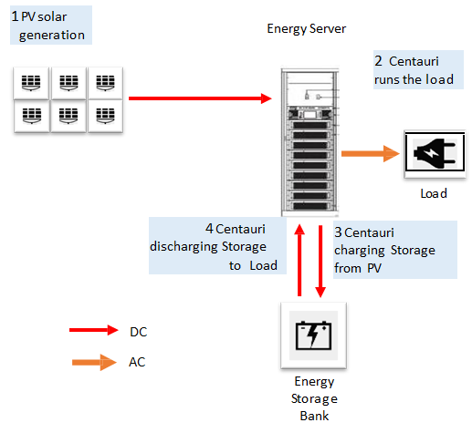  Advantages of Centauri  - Centauri is a singular, integrated, software and hardware platform. No additional hardware, software, switching, or monitoring solutions are required.  - High efficiency, resilience and error free operation  - Capacity can be increased with growing demand  - Centauri has design life of 20 years while Sirius has projected calendar life of 45 years  - No replacement or disposal cost  - PV Plant is optimized because of the high roundtrip efficiently  - Optimization of energy input sources  - Centauri can deliver sequential or blended power from input sources (AC/ DC)  Micro-Grid: Containerized Solution  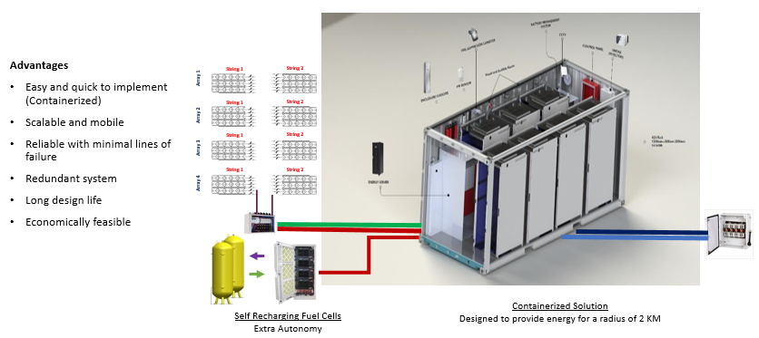  Note to Pui Ling – Please copy the diagrams from  https://drive.google.com/open?id=11PCDQo68y87AiwJyPE6PPL4Kspl1ycOF
Photos | https://drive.google.com/open?id=1SeR-AvNlNTAknpb0RUOwSnLNXqDZR-YT
Brochure | Please disable the “download brochure” button.
Inquiry Button | Link to PESTECH Energy Sdn. Bhd.
Inquiry Form Email To | pensales@pestech.com.my; info@pestech-international.com

- CAREER SECTION

Company Applied For | Email To
PESTECH International Berhad | career@pestech-international.com
PESTECH Technology Sdn. Bhd. | hr@pestech-technology.com
PESTECH Sdn. Bhd. | career@pestech-international.com
PESTECH Energy Sdn. Bhd. | career@pestech-international.com
PESTECH (Cambodia) PLC. | TBC
PESTECH (PNG) Ltd. | TBC
CRSE Sdn. Bhd. | hr@pestech-technology.com
Astoria Solar Farm Sdn. Bhd. | career@pestech-international.com
Fornix Sdn. Bhd. | career@pestech-international.com
Forward Metal Works Sdn. Bhd. | career@pestech-international.com
PESTECH (Sarawak) Sdn. Bhd. | career@pestech-international.com
PESTECH Power Sdn. Bhd. | career@pestech-international.com
PESTECH Power One Sdn. Bhd. | career@pestech-international.com
PESTECH Power Two Sdn. Bhd. | career@pestech-international.com
PESTECH REI Sdn. Bhd. | career@pestech-international.com
PESTECH Solutions Sdn. Bhd. | career@pestech-international.com
PESTECH Transmission Sdn. Bhd. | career@pestech-international.com
PESTECH Engineering Technology China Co. Ltd. | TBC
PESTECH (Myanmar) Limited | career@pestech-international.com
PESTECH Transmission Limited | career@pestech-international.com
PESTECH (Brunei) Sdn Bhd | career@pestech-international.com
Diamond Power Limited | TBC
Enersol Co. Ltd. | career@pestech-international.com
PESTECH Hinthar Corporation Limited | career@pestech-international.com
PESTECH System Siam Ltd. | career@pestech-international.com
PESTECH Vietnam Company Limited | career@pestech-international.com
PESTECH Microgrid Company Limited | career@pestech-international.com
ODM Power Line Company Limited | career@pestech-international.com

Note to Pui Ling – Please use this for the career form flow.
I will email the confirmed list on Monday.

